**Computer Network (PRACTICALS) – FALL 2012**

**EXPERIMENT 1 – INTRODUCTION TO COMPUTER NETWORKS**

|  |  |  |  |
| --- | --- | --- | --- |
| **DATE: 23 Sep 2012** | | **Student Name: Sumeer Riaz** | |
| **Marks Obtained: _____** | | **COURSE: BESE 16 B** | |
|  | | **Instructor: Lab Engr:**[**Kabeer Ahmed**](http://learn.mcs.edu.pk/user/view.php?id=95&course=1) | |
|  |  | |  |

**Q#1: Failure of node causes the failure of whole bus topology?**

**Answer:** Nodes are connected to a main (bus) cable. If the bus cable fails then the whole network will fail. Because only one node can send or receive data at a time and the data can be seen at every node but specific node accepts data addressed for it So, if the bus fails at a single point then the whole topology fails. The bus cable has a limited length and must be terminated properly at both ends to prevent reflected signals. **Also there is a mechanism to bypass the failed node so failure of one node will only affect that node**. But channel failure will cause whole network to fail.

**Q#2: Name network devices along with their functions?**

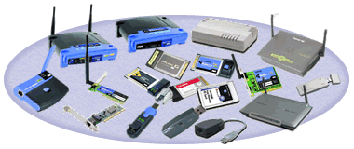**Answer:**

A computer network, or simply a network,

is A collection of [computers](http://en.wikipedia.org/wiki/Computers) and other [hardware](http://en.wikipedia.org/wiki/Networking_hardware) components interconnected by communication channels that allow sharing of resources and information.Where at least one process in one device is able to send/receive data to/from at least one

Process residing in a remote device, then the two devices are said to be in a network. Simply, more than one computer interconnected through a communication medium for information interchange is called a computer network.To develop network following network communication devices are required which are listed below:

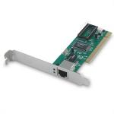

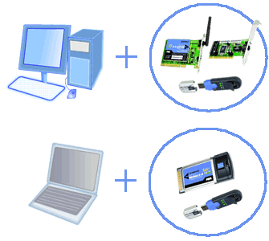**NIC Adapters:**

NIC is Network Interface Card; this is the most important device in building network. These adapters are the most common part of computers which are used in our homes and offices. Nic is also referred to LAN, i.e. is Local area network card. Communication mediums (cables) are attached to this card to build network.

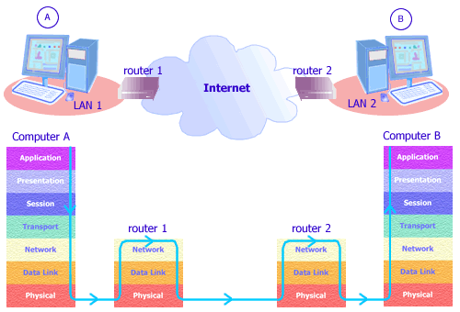**Routers:**

Routers operate at Layer3 of the OSI Layer and is categorized in the Network Layer. It can be programmed to find the best routes between networks, traverse many networks and is capable of choosing the best route to the destination. Offices in different and remote locations can be connected together using routers using dedicated or switched lines. The lines are usually provided by telephone companies or Internet 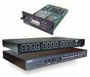Service Providers (ISPs). it is a device which routes data to destination computers. It helps in connecting two different logical and physical networks together. In small network server is connected to router along with clients for communication. Major companies which know for manufacturing routers and wireless routers are Tp Link, Cisco systems, Nortel, D link etc.

**333Hubs:**

Hubs are required to build network. All computers are connected directly to the hub as hub performs as centralized device the network. When data is sent to the hub it broadcasts the data to all the ports of the hub and then it is sent to destination computer on the network. If hubs

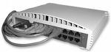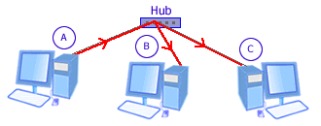

fails to perform its routine functions it will halt the working of the entire network until it is put back in normal condition.

**Switches**:

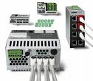It is used at the same place as hub is, but the only difference between the two is that switch possess switching table with in it. Switching tables store the MAC addresses of every computer 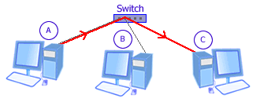

it is connected to and send the data to only requested address unlike hub which broadcasts the data too all the ports. Switches can be considered advance form of hubs.

**Gateways**: Gateways can be software or it can also be device. Gateway device connects LAN with internet. Its basic functionality is to provide security to the network. By using gateways incoming/out going traffic can be monitored for any malicious activity within the network which can be harmful to network integrity. Gateway functions to connect two completely different networks. It performs protocol translation. Although gateway is considered a Layer 7 device in many publications, it actually works across the seven layers of the [OSI Model](http://www.conniq.com/Glossary_O.htm#OSI). In Internet Telephony, a gateway connects the [VoIP](http://www.conniq.com/Glossary_V.htm#VoIP) network to the [PSTN](http://www.conniq.com/Glossary_P.htm#PSTN).

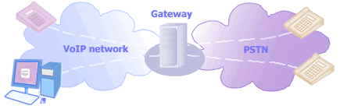

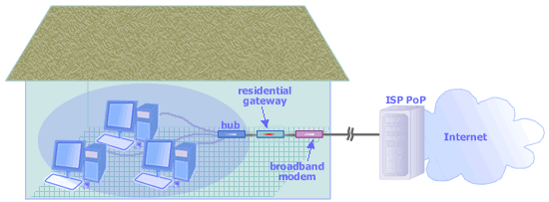It is basically a router that is configured to enable the sharing of a single Internet connection (subscription) by multiple users in a home network. However when you buy a residential gateway, it most likely incorporates other functions such as hub, switch, wireless access point, or bridge. **Some residential gateways also already include broadband (cable/DSL) modem**.

**Modems:**  
Modems can be of two types. One modem is very common in every computer which we use to connect to internet using our telephone line by dialing to our ISP and the other one is used to



connect to DSL. Functions however are same for both types of modems; they are used for modulation and demodulation, they are used to convert analog signals into digital and digital signals into analog so that signals can be travelled on telephone lines.

**Cables**:

Cables are obviously used to connect communication devices with each other to form network. There different types of cables, commonly used cables are 10baseT/CAT5 , coaxial cable, Ethernet and fiber optical cable. Fiber optical is the most expensive as it enables the data transfer at speed of light. It is costly solution which is mostly get adopted by corporate sector. However in recent developments optical fiber cable is now being used in home networking and also used as medium to connect to internet.

The following table explains network components along with their functions and the corresponding layers in the OSI Model.

|  |  |  |  |
| --- | --- | --- | --- |
| **Network Component** | | **Functions** | **OSI Model** |
| [**Network Adapter**](http://www.conniq.com/Networking_Components2.htm#Network Adapter) | | Converts a computer message into electrical/optical signals for transmission | Physical (Layer 1) |
| [**Modem (Modulator demodulator)**](http://www.conniq.com/Networking_Components3.htm#Modem) | | Puts a message (baseband signal) on a carrier for efficient transmission; takes the baseband signal from the carrier. | Physical (Layer 1) |
| [**Repeater (Regenerator)**](http://www.conniq.com/Networking_Components4.htm#Repeater) | | Receives signal, amplifies it, then retransmits it. | Physical (Layer 1) |
| [**Bridge**](http://www.conniq.com/Networking_Components4.htm#Bridge) | | Connects networks with different Layer 2 protocols; divides a network into several segments to filter traffic. | Data Link (Layer 2) |
| [**Hub**](http://www.conniq.com/Networking_Components5.htm#Hub) | | Connects computers in a network; receives a packet from a sending computer and transmits it to all other computers. | Physical (Layer 1) |
| [**Switch**](http://www.conniq.com/Networking_Components5.htm#Switch) | | Connects computers in a network; receives a packet from a sending computer and transmits it only to its destination. | Data Link (Layer 2) |
| [**Access Point**](http://www.conniq.com/Networking_Components6.htm#Access Point) | | Connects computers in a wireless network; connects the wireless network to wired networks; connects it to the Internet. | Data Link (Layer 2) |
| [**Router**](http://www.conniq.com/Networking_Components7.htm#Router) | | Forwards a packet to its destination by examining the packet destination network address. | Network (Layer 3) |
| [**Gateway**](http://www.conniq.com/Networking_Components8.htm#Gateway) | | Connects two totally different networks; translates one signalling/protocol into another. | All layers |
|  | | | |